***INTRODUCTION TO BOOTSTRAP***

1. **Create HTML for web-page.jpg using bootstrap**

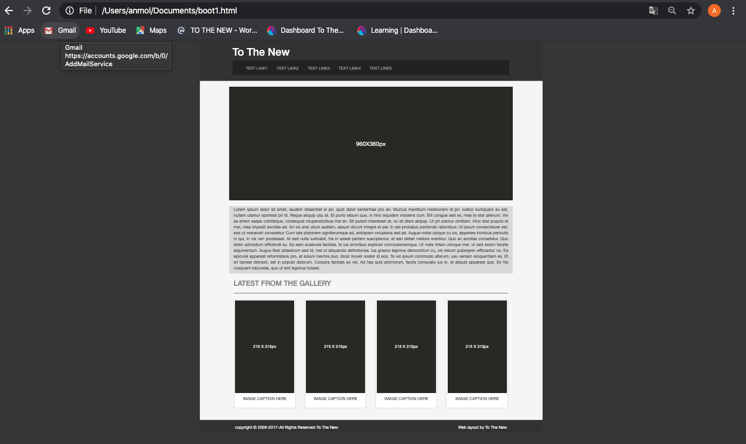

1. **Create HTML for form.png using bootstrap**

